

COMSATS University Islamabad, Abbottabad Campus.

**Submitted by:**

* Syed Ghazi Raza

**FA22-BSE-082**

**Submitted to:**

* **(**Sir**)** Mukhtaiar Zamin

**Section:**

* BSE-5B

**Topic:**

* Diagrams Report for Project Title **“AI-Powered Music Recommendation System”.**

**c**

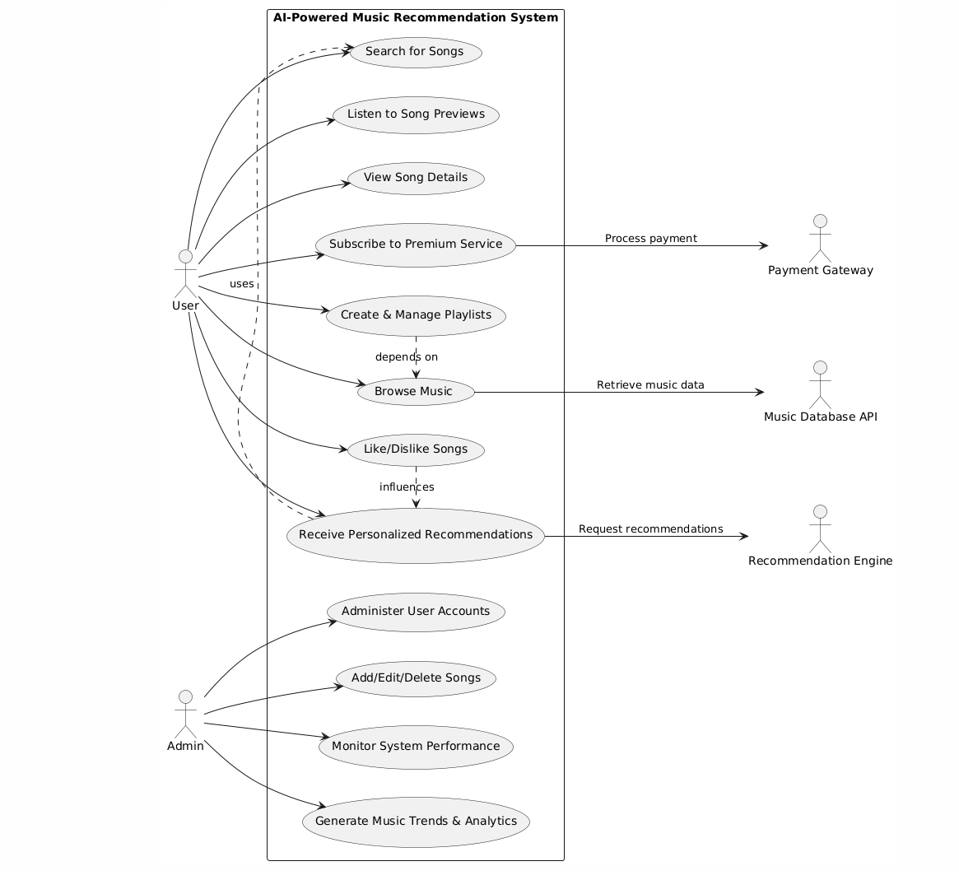

**Fully Dressed Use-Case**

**Use Case Name: Create & Manage Playlists**

| **Item** | **Description** |
| --- | --- |
| **Use Case ID** | UC4 |
| **Use Case Name** | Create & Manage Playlists |
| **Actor** | User |
| **Secondary Actors** | None |
| **Preconditions** | - User must be logged in. - System must display a playlist creation interface. |
| **Postconditions** | - The playlist is successfully created, edited, or deleted. - Changes are reflected in the user’s profile. |
| **Normal Flow** | 1. User selects the option to create a playlist. 2. The system prompts the user to enter a playlist name. 3. User adds songs to the playlist. 4. User can edit or remove songs from the playlist. 5. User saves the playlist. 6. The system confirms the playlist creation. 7. User can edit the playlist later (rename, add/remove songs). |
| **Alternative Flow** | **A1**: Editing an Existing Playlist 1. User selects an existing playlist to edit. 2. System displays playlist details. 3. User makes changes (rename, add, or remove songs). 4. System updates the playlist.   **A2**: Deleting a Playlist 1. User selects an option to delete a playlist. 2. System prompts for confirmation. 3. Upon confirmation, system deletes the playlist. |
| **Exception Flow** | **E1**: System error during playlist creation - If there is a system error while creating or saving a playlist, the system displays an error message and allows the user to retry. **E2**: Playlist name already exists - If the user attempts to create a playlist with a duplicate name, the system prompts them to choose another name. |
| **Priority** | High |
| **Frequency of Use** | Frequent |
| **Assumptions** | - The user is familiar with the playlist feature. - The system allows editing and managing playlists without needing admin privileges. |
| **Special Requirements** | - The system should support large playlists (up to 500 songs). - Fast and responsive user interface for managing playlists. |
| **Open Issues** | None |

**System Sequence Diagram**

**Use Case Name: Create & Manage Playlists**

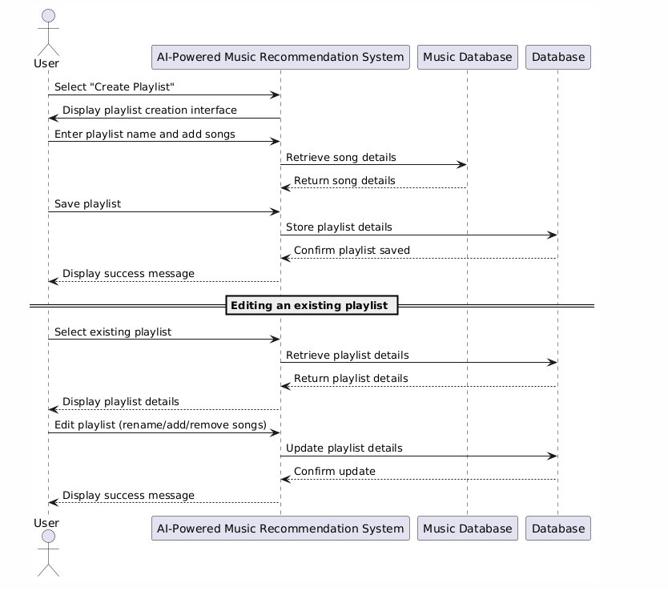

**Communication Diagram**

**Use Case Name: Create & Manage Playlists**

